|  |  |
| --- | --- |
| **The influence of pricing and advertising on customer pleasure as mediated by purchase decisions**  Yohanes Ferry Cahaya,1,* Friska Putri Nofzil,2 Sri Yanthy Yosepha,3 Herni Pujiati,4Eddy Setyanto5  1,3,4 Universitas Dirgantara Marsekal Suryadarma  2 Perbanas Institute  5 Sekolah Tinggi Ilmu Ekonomi Tri Bhakti  *Corresponding author: [ferry@unsurya.ac.id](mailto:ferry@unsurya.ac.id) | |
|  |  |
| ***Article history***  ***Received:***  *23-04-2022*  ***Accepted:***  *09-10-2024*  ***Published:***  *18-10-2024*  *Copyright © 2022 Management Research Studies Journal Description: C:\Users\178\Desktop\图片1.emf* | ***Abstract***  *This study aims to examine the influence of price and advertising on consumer satisfaction through purchase decisions. This study employs a quantitative methodology. This study utilized a sample of 100 participants from the Shopee program. The questionnaire results provided the research data, which was analyzed using the SEM PLS method through the SmartPLS 3.0 application. The results of this study indicate that: (1) Price has a positive and substantial impact on purchase decisions. Advertising elements significantly and positively impact purchasing decisions. Acquisition decisions significantly and positively impact client satisfaction. The coefficient of determination for consumer satisfaction is 0.681. Price, advertising, and purchasing decisions constitute 68.1% of the variance in consumer satisfaction among users of the Shopee program, while other factors account for the remaining 31.9%.*  ***Keywords*: *price, advertising, customer satisfaction, purchase decision*** |
|  |  |

**INTRODUCTION**

In the age of globalization, rivalry among businesses in both domestic and foreign marketplaces is intensifying. Business professionals leverage internet technology to achieve innovations, specifically online sales, commonly referred to as e-commerce, in response to contemporary rivalry. Miftah Maulana et al. (2017) define e-commerce as the electronic buying and selling of things between customers and businesses, utilizing computers as mediators for transactions. E-commerce denotes any transaction activity involving the buying and selling of products or services via electronic platforms. Rante Rerung (2018) identifies the features of e-commerce as infinite transactions, anonymous transactions, digital or non-digital products, and intangible goods. Moreover, the rationale for company expansion is underscored by the annual increase in internet usage in Indonesia. This is evidenced by a poll performed by Asosiasi Penyelenggara Jasa Internet (APJII) as follows:

**Table 1 The number of Internet users in Indonesia 2017-2022**

|  |  |
| --- | --- |
| Year | Number of Users |
| 2017 | 143,26 juta |
| 2018 | 171,18 juta |
| 2019 | 196,7 juta |
| 2020 | 196,7 juta |
| 2021 | 203 juta |
| 2022 | 210 juta |

Source : Asosiasi Penyelenggara Jasa Internet Indonesia (APJII), 2017

Since its inception in Southeast Asia, the Shopee application has become an easily accepted application because the Southeast Asian region is a region whose population has a very high interest in social media. Research (iPrice and App Annie, 2019) reveals that active users of e-commerce applications in Indonesia and the Southeast Asian region hold the highest monthly and average ranking of e-commerce application downloaders across both iOS and Android platforms. Iprice's study results clearly demonstrate this.

**Table 2 Top 5 *E-commerce* in Indonesia 2018 – 2021**

|  |  |  |
| --- | --- | --- |
| No | e-commerce site | Number of visits (million) |
| 1 | Shopee | 96.532.300 |
| 2 | Tokopedia | 84.997.100 |
| 3 | Bukalapak | 31.409.200 |
| 4 | Lazada | 22.674.000 |
| 5 | Blibli | 18.695.000 |

Source: Iprice

Shopee's operations in Indonesia represent 40% of its global business portfolio. As of 2021, 203 million persons globally downloaded the Shopee application, with 33.27 million downloads from Indonesia. This outcome indicates the efficacy of Shopee's initiative to promote internet shopping among Indonesians. Examples of campaigns executed by Shopee includeShopee has executed several successful initiatives in the past year, including discounts, flash sales, free delivery, and targeted promotional events, which have demonstrated considerable success.

The factor that significantly influences customer purchasing decisions is pricing. Variations in pricing between e-commerce platforms render consumers more discerning in their decision-making. The price is frequently linked to the advantages perceived from the consumer's perspective. Wastha Irawan (2020) defines price as the monetary amount (together with several products, if applicable) required to acquire a specific assortment of goods and services. Individual perceptions of pricing differ while making purchasing decisions. Tiptono (2016) asserts that price is the sole marketing element that produces income or revenue for the organization.

Shopee employs many techniques to address e-commerce competition in Indonesia, particularly in the realm of communication, with advertising being a key component. Advertising seeks to influence the public to ensure the company's strategy is effective and generates profit. According to Rewoldt (2017), the term "advertisement" originates from Greek. Advertising is defined as all acts that non-personally communicate and promote ideas, goods, or services, funded by specific sponsors. As stated by Suyanto (2018), advertising entails the utilization of various media by sellers to convey persuasive information on items, services, or organizations, serving as a potent promotional instrument.

Consumers make purchasing decisions based on their needs. Tiptono (2016) characterizes consumer behavior as actions directly associated with the procurement and assessment of items and services, including the decision-making process that transpires both prior to and subsequent to these activities. Consumers must traverse the entire sequence of stages while purchasing a product, as this model encompasses all elements that arise during high-involvement transactions.

Consumer satisfaction is derived when people evaluate their purchasing experiences against their own expectations of sellers or service providers. These expectations are shaped by initial shopping experiences, feedback from peers, and assertions and information provided by marketers and competitors. Irawan D & Park (2021) define consumer satisfaction as a customer's emotional response to a consumed product or service.

Researchers have performed numerous research on purchase decisions and customer satisfaction. Nevertheless, the conclusions still yield disparate results. Research (Istanti, 2017) indicates that the price variable significantly affects purchasing decisions. IdenticalHeri Susilo et al. (2018) asserted that price and advertising variables greatly affect consumer satisfaction via purchase decisions.Although many prior research findings demonstrate a favorable and considerable influence of price and advertising, several other studies produce contrasting outcomes. Research by Hidayat et al. (2017) indicates that the price variable does not influence purchasing decisions.

**LITERATURE REVIEW AND HYPOTESES DEVELOPMENT**

Tiptono (2017) defines price as a monetary unit or other measure (including other products and services) transferred to acquire the right to possess or utilize a good or service. Kotler & Armstrong (2012) identify four characteristics that characterize prices: price affordability, price alignment with product quality, price alignment with benefits, and price competitiveness based on ability.

Advertising: a mechanism for directing persuasive communication towards target consumers and the general public. Advertising, as defined by Suyanto (2018), is the utilization of various media by vendors to convey information. It is compelling regarding products, services, or organizations and serves as an effective promotional instrument. As stated by Kasali (2018), advertising constitutes a component of the promotional mix, which in turn is a subset of the marketing mix. Advertising seeks to elicit a favorable response that advantages the organization, specifically by generating customer interest in purchasing the product and enhancing the company's image through various media. According to Widayatmoko (2019), the aspects of advertising include meaningfulness, distinctiveness, and believability.

As stated by Alma (2016), a purchasing decision is a customer choice influenced by financial economics, technology, politics, culture, items, prices, places, promotions, physical evidence, individuals, and processes. This cultivates a consumer disposition to analyze information and formulate answers to product purchases. Tiptono (2012) asserts that consumer purchasing decisions encompass multiple dimensions, including product selection, brand selection, distributor selection, timing of purchase, quantity of purchase, and payment mode.

Sunyoto (2015) asserts that consumer satisfaction is a key factor influencing consumers' decisions to shop at a particular location. When consumers are content with a product, they are likely to persist in purchasing and utilizing it, and they share their positive experiences with others. Tiptono (2014) asserts that consumer satisfaction encompasses seven primary dimensions: quality of goods and services, relationship marketing, loyalty service programs, prioritization of best customers, effective management systems, unconditional guarantees, and pay-for-performance initiatives.

Consumers can evaluate and regulate a product according to its cost. The price of a thing, regardless of being costly or inexpensive, is significantly relative. Prior to substantiating it, juxtapose it with the pricing of analogous products from different companies. Companies must meticulously observe the pricing strategies of their competitors to guarantee that their own prices are not prohibitively high, or alternatively, to ensure that their prices attract consumer purchases. A strong correlation exists between price and purchase decisions. The research conducted by Istiqomah, Zainul Hidayat, and Ainun Jariah in 2019 proposes the following hypothesis:  
H1: The price substantially influences the purchasing decisions of users of the Shopee application.

The efficacy of an advertisement, or the impact of its impression, is determined by its ability to capture the audience's attention. The efficacy of an advertisement is determined by its capacity to engage the audience's attention. One of the most effectiveAdvertising is a highly effective strategy for introducing a product to people, with the objective of stimulating their interest.Advertising and purchasing decisions are closely interconnected. The 2018 study by Febri Susanti and Chynthia Mulyani proposes the following hypothesis:

H2: Advertising significantly influences the purchasing decisions of Shopee application users.

Purchasing decisions can alter human cognitive patterns, as customers evaluate their demands through logical reasoning. A consumer will select a product that demonstrates superior effectiveness, efficiency, and alignment with their requirements. Consumers attain satisfaction by selecting a product that aligns with their wants and desires, thereafter evaluating it against rival offerings. Increased purchasing decisions for a product correlate with elevated consumer satisfaction. Toni Johanes, Demak Claudia, Yosephine Simanjuntak, Vicdy Anche Salimi, and Vincet Louis did prior study in 2020 that substantiates the following hypothesis:

H3: Purchasing decisions substantially influence consumer pleasure.

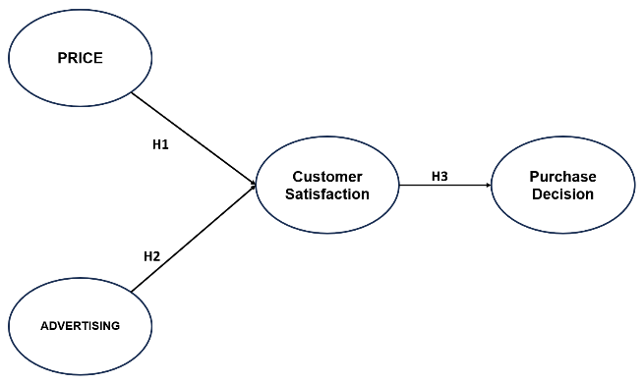

Figure 1. Research model

**METHOD**

This study utilizes a quantitative research methodology, gathering data via a questionnaire from a sample of 100 dedicated users of the Shopee program. This study has two independent variables, one mediating variable, and one dependent variable. The independent variables are pricing and advertising expenditure. The independent variable is the purchasing decision, whereas the mediating variable is consumer satisfaction. This study examines the direct impact of pricing and advertising on purchasing decisions.

.

**RESULTS**

The respondent profile in this study includes gender, age, residential area, education, and occupation.

**Table 3 Respondent Characteristics**

|  | Characteristics | Total | Persentase |
| --- | --- | --- | --- |
| Gender | Male | 23 | 23% |
| Female | 77 | 77% |
|  | | | |
| Age | 18 – 23 tahun | 30 | 30% |
| 24 – 29 tahun | 68 | 68% |
| 30 – 35 tahun | 2 | 2% |
| Residential Area | Jakarta | 59 | 59% |
| Bogor | 17 | 17% |
| Depok | 9 | 9% |
| Tangerang | 9 | 9% |
| Bekasi | 6 | 6% |
|  | | | |
| Job | Pelajar/ Mahasiswa | 33 | 33% |
| PNS | 2 | 2% |
| BUMN | 9 | 9% |
| Karyawan Swasta | 46 | 46% |
| Wiraswasta | 10 | 10% |
|  | | | |
| Education | SMA/ SMK | 19 | 19% |
| Diploma | 22 | 22% |
| Sarjana | 57 | 57% |
| Pascasarjana | 2 | 2% |
|  | | | |
| Penghasilan | 500 rb – 1 jt | 20 | 20% |
| 1 jt – 3 jt | 21 | 21% |
| 3 jt – 5 jt | 28 | 28% |
| >5 jt | 31 | 31% |

Source: processed by researchers

**External Analysis**

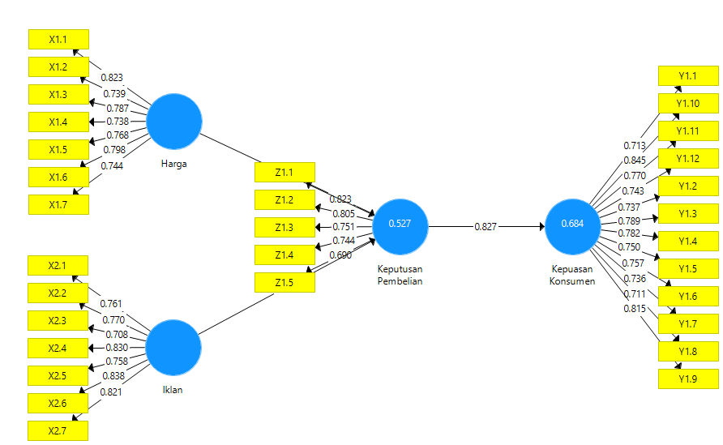This study adopts the Structural Equation Modeling (SEM) technique, employing a path diagram to integrate all observed variables according to the constructed theoretical model. We employed Smart Partial Least Square (Smart PLS) SEM analysis, facilitated by the SmartPLS 3.0 software tool.

**Figure 2 Outer Model**

Source: SmartPLS data processing, 2023

**Convergent Validity**

Validity Convergence Each construct indicator is tested by Ghozali (2014), and if an indicator's value is more than 0.70, it is deemed to have good validity. Nonetheless, a loading factor value of 0.5 to 0.6 is still appropriate during the scale development phase. (2015) Ghozali et al.

**Table 4 Convergent Validity Test**

| Indicator | Loading Factor | Remark |
| --- | --- | --- |
| X1.1 | 0.823 | Valid |
| X1.2 | 0.739 | Valid |
| X1.3 | 0.787 | Valid |
| X1.4 | 0.738 | Valid |
| X1.5 | 0.768 | Valid |
| X1.6 | 0.798 | Valid |
| X1.7 | 0.744 | Valid |
| X2.1 | 0.761 | Valid |
| X2.2 | 0.770 | Valid |
| X2.3 | 0.708 | Valid |
| X2.4 | 0.830 | Valid |
| X2.5 | 0.758 | Valid |
| X2.6 | 0.838 | Valid |
| X2.7 | 0.821 | Valid |
| Z1.1 | 0.823 | Valid |
| Z1.2 | 0.805 | Valid |
| Z1.3 | 0.751 | Valid |
| Z1.4 | 0.744 | Valid |
| Z1.5 | 0.690 | Valid |
| Y1.1 | 0.713 | Valid |
| Y1.2 | 0.737 | Valid |
| Y1.3 | 0.789 | Valid |
| Y1.4 | 0.782 | Valid |
| Y1.5 | 0.750 | Valid |
| Y1.6 | 0.757 | Valid |
| Y1.7 | 0.736 | Valid |
| Y1.8 | 0.711 | Valid |
| Y1.9 | 0.815 | Valid |
| Y1.10 | 0.845 | Valid |
| Y1.11 | 0.770 | Valid |
| Y1.12 | 0.743 | Valid |

Source: SmartPLS data processing, 2023

According to the above table, each loading factor's value is determined for each variable's indicators; if any loading factor value is greater than 0.7, the study's validity is satisfied.

**Discriminant Validity**

Ghozali et al. (2015) state that the discriminant validity approach involves testing the discriminant validity using a reflective indicator, specifically by examining each variable's cross-loading value, which needs to be more than 0.7.

**Table 5 Test of Discriminant Validity**

| **Indicator** | **Price** | **Advertising** | **Customer Satisfaction** | **Purchase Decision** |
| --- | --- | --- | --- | --- |
| X1.1 | 0.823 | 0.631 | 0.529 | 0.539 |
| X1.2 | 0.739 | 0.493 | 0.430 | 0.484 |
| X1.3 | 0.787 | 0.540 | 0.479 | 0.508 |
| X1.4 | 0.738 | 0.635 | 0.515 | 0.488 |
| X1.5 | 0.768 | 0.557 | 0.570 | 0.515 |
| X1.6 | 0.798 | 0.666 | 0.496 | 0.532 |
| X1.7 | 0.744 | 0.571 | 0.522 | 0.497 |
| X2.1 | 0.624 | 0.761 | 0.581 | 0.573 |
| X2.2 | 0.665 | 0.770 | 0.559 | 0.560 |
| X2.3 | 0.469 | 0.708 | 0.482 | 0.511 |
| X2.4 | 0.557 | 0.830 | 0.431 | 0.519 |
| X2.5 | 0.571 | 0.758 | 0.459 | 0.502 |
| X2.6 | 0.638 | 0.838 | 0.582 | 0.623 |
| X2.7 | 0.624 | 0.821 | 0.541 | 0.528 |
| Z1.1 | 0.578 | 0.675 | 0.721 | 0.823 |
| Z1.2 | 0.486 | 0.580 | 0.646 | 0.805 |
| Z1.3 | 0.452 | 0.472 | 0.686 | 0.751 |
| Z1.4 | 0.575 | 0.481 | 0.550 | 0.744 |
| Z1.5 | 0.424 | 0.425 | 0.534 | 0.690 |
| Y1.1 | 0.505 | 0.344 | 0.713 | 0.480 |
| Y1.2 | 0.449 | 0.428 | 0.737 | 0.513 |
| Y1.3 | 0.537 | 0.502 | 0.789 | 0.626 |
| Y1.4 | 0.528 | 0.634 | 0.782 | 0.656 |
| Y1.5 | 0.445 | 0.495 | 0.750 | 0.616 |
| Y1.6 | 0.522 | 0.572 | 0.757 | 0.642 |
| Y1.7 | 0.516 | 0.590 | 0.736 | 0.650 |
| Y1.8 | 0.439 | 0.368 | 0.711 | 0.581 |
| Y1.9 | 0.501 | 0.492 | 0.815 | 0.704 |
| Y1.10 | 0.556 | 0.585 | 0.845 | 0.704 |
| Y1.11 | 0.521 | 0.540 | 0.770 | 0.727 |
| Y1.12 | 0.480 | 0.477 | 0.743 | 0.599 |

Source: SmartPLS data processing, 2023,

The cross-loading values in the table indicate that the discriminant validity of the aforementioned variables is satisfactory, as the cross-loading values for the latent variables exceed 0.7 for other latent variables.

**Composite Reliability Test**

The composite reliability value shows the results of the reliability test. According to Abdullah (2015), composite reliability has an approved limit value of 0.7 for the composition reliability level (PC).

**Table 6 Composite reliability test**

|  |  |  |
| --- | --- | --- |
| **Variable** | **Cronbach's Alpha** | **Composite Reliability** |
| Price | 0.886 | 0.911 |
| Advertising | 0.895 | 0.918 |
| Customer Satisfaction | 0.935 | 0.944 |
| Purchase Decision | 0.822 | 0.875 |

Source: SmartPLS data processing, 2023

According to the above table, each latent variable's Cronbach's alpha and composite reliability values were found to be greater than 0.7, indicating that the reliability test in this investigation was successful.

**One Order Confirmatory Test**

Factor Analysis This study incorporates the construct model into the one-order model, where all variables utilize items from the path coefficient table. The path coefficient ranges from -1 to +1, with a value closer to -1 indicating a negative relationship between the variables (Hair, 2017).

**Table 7 Path Coeffiecient**

|  |  |
| --- | --- |
| **Hypothesis** | **Coefisien** |
| Price 🡪 Purchase Decision | 0.307 |
| Advertising 🡪 Purchase Decision | 0.465 |
| Purchase Decision 🡪 Customer Satisfaction | 0.827 |

Source: SmartPLS data processing, 2023, 2023

* The price variable and the purchase choice have a positive link, as indicated by the path coefficient of the price variable to the buy decision, which is 0.307.
* The advertising variable and the purchase decision have a positive link, as indicated by the path coefficient of the advertising variable to the buy decision, which is 0.465.
* A positive association between the purchase choice variable and customer happiness is indicated by the path coefficient of the buy decision variable to consumer satisfaction, which is 0.465.

**Inner Analysis**

This study's inner model, referred to as the structural model, delineates the relationship between latent variables and illustrates the connection between the research's substantive theory and these latent variables (Jaya, 2008).

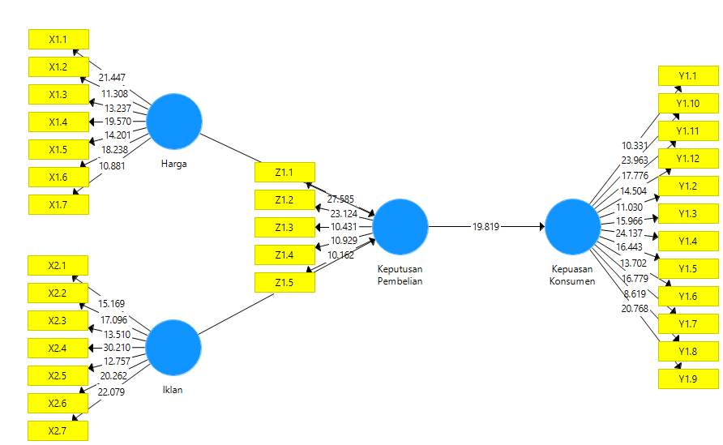

**Figure 3 Inner Model**

Source: SmartPLS data processing, 2023

**R-Square**

The R-squared value varies from 0 to 1, with elevated values signifying a more substantial influence of exogenous variables on endogenous variables (Hair, 2017).

**Table 8 R-Square Test**

|  |  |  |
| --- | --- | --- |
| **Variable** | **R Square** | **R Square Adjusted** |
| Customer Satisfaction | 0.684 | 0.681 |
| Purchase Decesion | 0.527 | 0.518 |

Source: SmartPLS data processing, 2023

The table above indicates that the independent variable affects the moderating variable by 68.4%, whereas variables excluded from this study account for the remaining 21.6%.

The moderation variable exerts an influence of 52.7% on the dependent variable, with the remaining 47.3% attributable to variables excluded from this study.

**Q2 Predictive Relevance**

A Q2 value greater than 0 signifies that the model possesses predictive significance, whereas a Q2 value less than 0 denotes diminished predictive relevance (Ghozali et al., 2015).

**Table 9 Q-Square Test**

|  |  |  |  |
| --- | --- | --- | --- |
| **Variable** | **SSO** | **SSE** | **Q² (=1-SSE/SSO)** |
| Price | 700.000 | 700.000 |  |
| Advertising | 700.000 | 700.000 |  |
| Customer Satisfaction | 1200.000 | 750.286 | **0.375** |
| Purchase Decision | 500.000 | 356.258 | **0.287** |

Source: SmartPLS data processing, 2023

The Q-Square value for the consumer satisfaction variable, as indicated in the table above, is 0.375, signifying that the Q2 value exceeds 1, therefore categorizing the model as effective. The Purchase Decision variable produces a Q2 value of 0.287, signifying a Q2 greater than 1, therefore validating the model's favorable condition.

**Quality Index**

To compute the Goodness of Fit (GoF), the square root of the mean communality index and mean R-Squared values is utilized, following the method established by Tanenhaus et al. (2004) as referenced in Ghozali et al. (2015): √ Description: GoF = Goodness of Fit, Com = Average Communality Index, R = Average R-Squared. The Goodness of Fit (GoF) value thresholds are 0.10 (small), 0.25 (mid), and 0.36 (big) (Ghozali et al., 2015).

**Table 10 Goodness of Fit Test**

|  |  |  |  |
| --- | --- | --- | --- |
| **Variable** |  | **R Square** | **Average R-Square** |
| Customer Satisfaction |  | 0.684 | 0.605 |
| Purchase Decision |  | 0.527 |

Source: SmartPLS data processing, 2023

The average r-square value, as seen in the table above, is 0.605, signifying a GoF value beyond 0.36; hence, it can be concluded that the model has a substantial influence (GoF Large).

**SRMR**

The PLS model is considered to satisfy the goodness of fit criteria if the SRMR value is less than 0.10, and it is deemed a perfect match if the SRMR value is less than 0.08.

**Tabel 11 SRMR Test**

|  |  |  |
| --- | --- | --- |
| **GoF** | **Saturated Model** | **Estimated Model** |
| SRMR | 0.076 | 0.083 |

Source: SmartPLS data processing, 2023

The SRMR value derived from this investigation was 0.083; based on the criterion of SRMR <0.1, it can be inferred that the model demonstrates goodness of fit.

**Hypothesis Testing**

Hypotheses can be evaluated using t-statistics and p-values. Detection is based on the assumed statistical value; for an alpha level of 5%, the t-statistic employed is 1.96 (Muniarti et al., 2013).

1. **Direct Effect Examination**

The bootstrap resampling technique employs a significance threshold of 1.96 (significance level = 5%).

**Table 12 t Test**

|  |  |  |
| --- | --- | --- |
| **Hypothesis** | **T Statistics (|O/STDEV|)** | **P Values** |
| Price 🡪 Purchase Decision | 2.216 | 0.027 |
| Advertising 🡪 Purchase Decision | 3.756 | 0.000 |
| Purchase Decision 🡪 Customer Satisfaction | 19.819 | 0.000 |

Source: SmartPLS data processing, 2023

The t-statistic and p-value for each variable are derived from the table above, after which the researcher will evaluate the formulated hypothesis.

* Price 🡪 Purchase Decision

According to the table above, the t-statistic is 2.216 and the p-value is 0.027. Given a confidence level of 0.05, the condition 0.027 < 0.05 indicates that the price variable significantly influences the purchase decision variable.

* Advertising 🡪 Purchase Decision

According to the table above, the t-statistic is 3.756 and the p-value is 0.000. With a confidence level of 0.05, the condition 0.000 < 0.05 indicates that the advertisement variable significantly influences the purchase decision variable.

* Purchase Decision 🡪 Customer Satisfaction

According to the table above, the t-statistic is 19.819 and the p-value is 0.000 at a confidence level of 0.05; hence, 0.000 < 0.05 indicates that the purchase choice variable significantly influences the consumer satisfaction variable.

1. **Mediation Effect Test**

Examining the mediation effect in the study utilizing PLS according to the methodology established by Baron and Kenny (1998, in Ghozali and Latan, 2015). The t-statistic employed was 1.96 (significance level = 5%).

**Table 13 Mediation Effect Test**

|  |  |  |
| --- | --- | --- |
| **Hypothesis** | **T Statistics (|O/STDEV|)** | **P Values** |
| Price 🡪 Purchase Decision 🡪 Customer Satisfaction | 2.158 | 0.031 |
| Advertising 🡪 Purchase Decision 🡪 Customer Satisfaction | 3.604 | 0.000 |

Source: SmartPLS data processing, 2023

The t-statistic and p-value for each variable are derived from the aforementioned table, after which the researcher will evaluate the formulated indirect impact.

* Price 🡪 Purchase Decision 🡪 Customer Satisfaction

The t-statistic is 2.158 and the p-value is 0.031, with a confidence level of 0.05. Since 0.031 is less than 0.05, it indicates that the price variable significantly influences consumer satisfaction through the mediation of purchasing decisions

* Advertising 🡪 Purchase Decision 🡪 Customer Satisfaction

The t-statistic value is 3.604 and the p-value is 0.000, indicating that the advertising variable significantly influences consumer happiness through the mediation of purchase decisions, as 0.000 is less than the 0.05 confidence level.

**DISCUSSION**

* The cost affects buying choices.

This study has demonstrated that price exerts a positive and significant influence on purchasing decisions, indicating that a more advantageous price leads to more favorable purchasing choices. The findings of this study align with the research conducted by Istiqomah, Zainul Hidayat, and Ainun Jariah in 2019, which indicated that pricing significantly influences purchase decisions.

* Advertising affects consumer purchasing choices.

This study has demonstrated that advertising exerts a favorable and significant influence on purchasing decisions, indicating that more well marketed advertisements will result in improved purchasing choices. The findings of this study align with the research conducted by Febri Susanti and Chynthia Mulyani in 2018, which shown that advertising significantly influences purchasing decisions.

* The influence of purchase choices on customer satisfaction is apparent. This study validates and confirms Hypothesis 3, indicating that purchase decisions have a large and beneficial impact on consumer happiness. This indicates that an elevated purchasing decision results in increased consumer satisfaction. The findings of this study align with the research conducted by Toni Johanes, Demak Claudia, Yosephine Simanjuntak, Vicdy Anche Salimi, and Vincet Louis in 2020, indicating that purchase decisions significantly influence consumer pleasure.

**CONCLUSION**

In summary, price exerts a positive and considerable influence on consumer satisfaction via the mediation of purchasing decisions. Advertising positively and significantly influences consumer happiness by moderating purchasing decisions. Acquisition choices provide a favorable and substantial influence on customer contentment. Ultimately, pricing, advertising, and purchasing decisions substantially influence consumer happiness among users of the Shopee program. This research has focused on a certain segment of the target demographic. Consequently, there exists the opportunity to incorporate a broader demographic to achieve more precise outcomes. through Researchers could augment the study by integrating characteristics such as product quality, service quality, location, or by employing an alternative research subject from the present investigation. Other studies can also reevaluate additional indicators of pricing, advertising, and purchasing actions that influence consumer happiness.

**REFERENCES**

Alma, B. (2016). *Manajemen Pemasaran dan Pemasaran Jasa*. Alfabeta.

Ghozali, imam, & Latan, H. (2015). *Konsep, Teknik, Aplikasi Menggunakan Smart PLS 3.0 Untuk Penelitian Empiris*.

Harga, P., Berbelanja, K., Istanti, F., Studi Administrasi Bisnis, P., & NSC Surabaya, P. (n.d.). *ONLINE DI KOTA SURABAYA*. www.apjii.or.id

HM, J. (2008). *Model Kesuksesan Sistem Teknologi Informasi.* Andi.

Irawan D, H., & Park. (2021). *Prinsip Kepuasan Pelanggan.* Elex Media Komputindo.

Kotler, P., & Amstrong, G. (2012). *Prinsipprinsip pemasaran*. Erlangga.

Miftah Maulana, S., Susilo, H., & Riyadi. (2015). *Implementasi E-commerce Sebagai Media Penjualan Online (Studi Kasus Pada Toko Pastbrik Kota Malang)*.

Rante Rerung, R. (2018). *E-Commerce Menciptakan Daya Saing Melalui Teknologi Informasi*.

Rewoldt. (2017). *Strategi Promosi Pemasaran*.

Rhenald, K. (n.d.). *Manajemen Periklanan: Konsep dan Aplikasinya di Indonesia*. Pustaka Utama Gravity.

Rozi, I. A. (n.d.). *Khuzaini Sekolah Tinggi Ilmu Ekonomi Indonesia (STIESIA) Surabaya*.

Simanjuntak, D. C. Y., Salimi, V. A., Louis, V., & Johanes, T. (2020). Pengaruh Kepuasan Pelanggan, Kepercayaan Pelanggan Dan Saluran Distribusi Terhadap Keputusan Pembelian Baja Pada Pt Suminsuryamesindolestari. *E-Jurnal Manajemen Universitas Udayana*, *9*(7), 2872. https://doi.org/10.24843/ejmunud.2020.v09.i07.p20

Sugiyono. (2019). *Metode Penelitian Kuantitatif, Kualitatif, dan R&D*. Alfabeta.

Suyanto, M. (2018). *Aplikasi Desain Grafis Untuk Periklanan*. Andi.

Swashta Irawan, B. (2020). *Manajemen Pemasaran Modern*. Liberty Yogyakarta.

Tjiptono, F. (2016). *Strategi Pemasaran.*

.